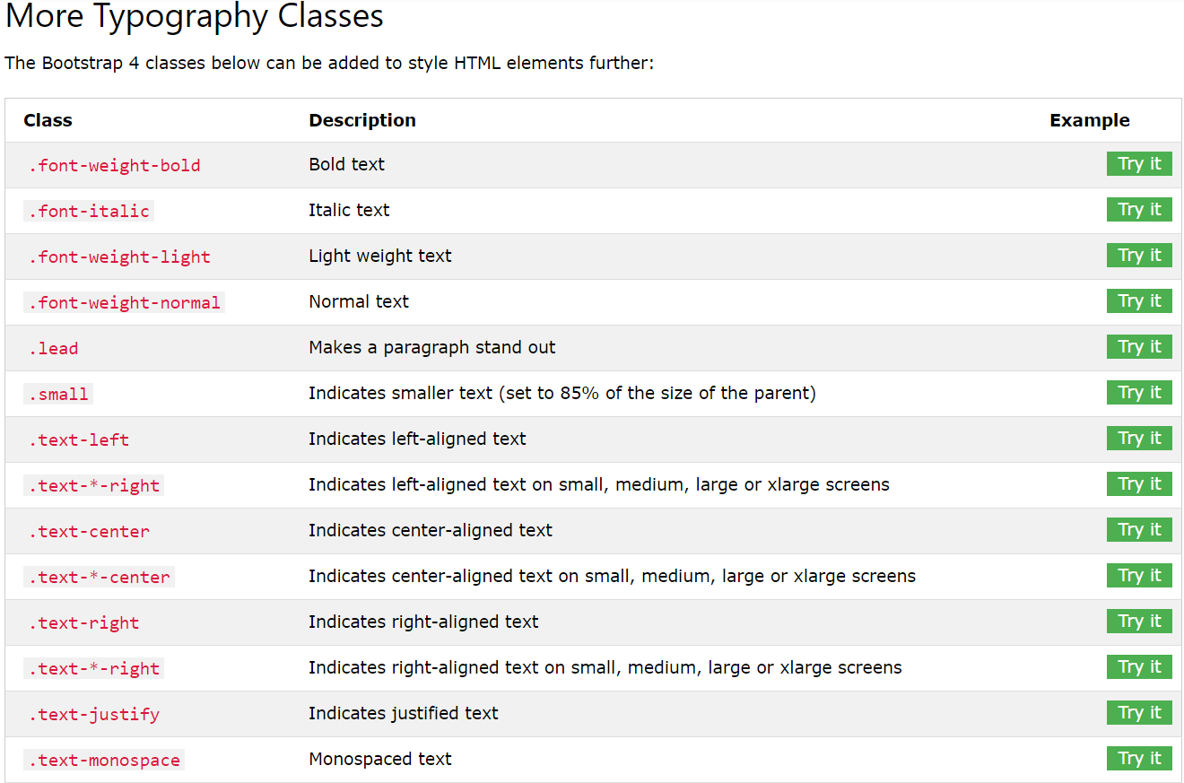

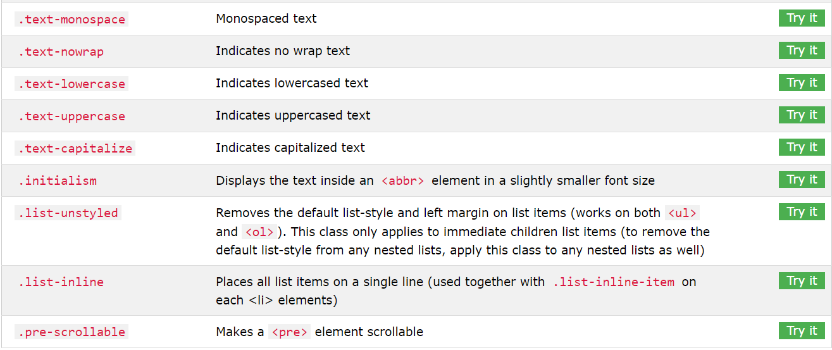

Background Colors

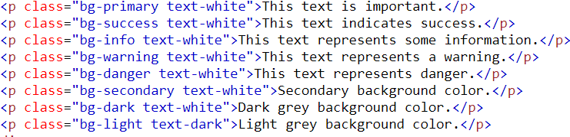

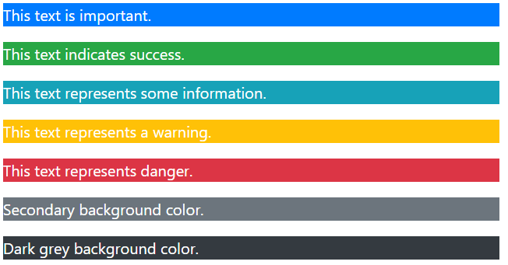

## Table

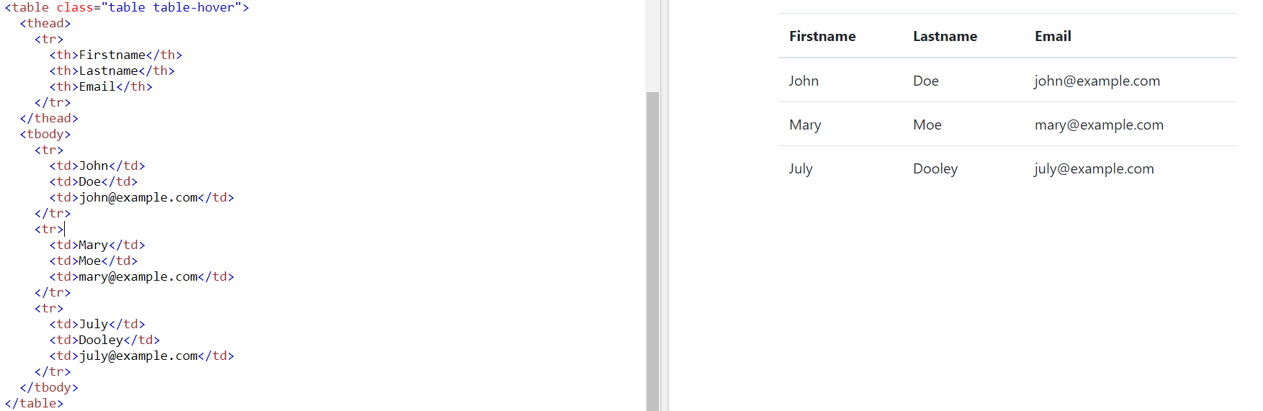

# **Bootstrap 4 Images**

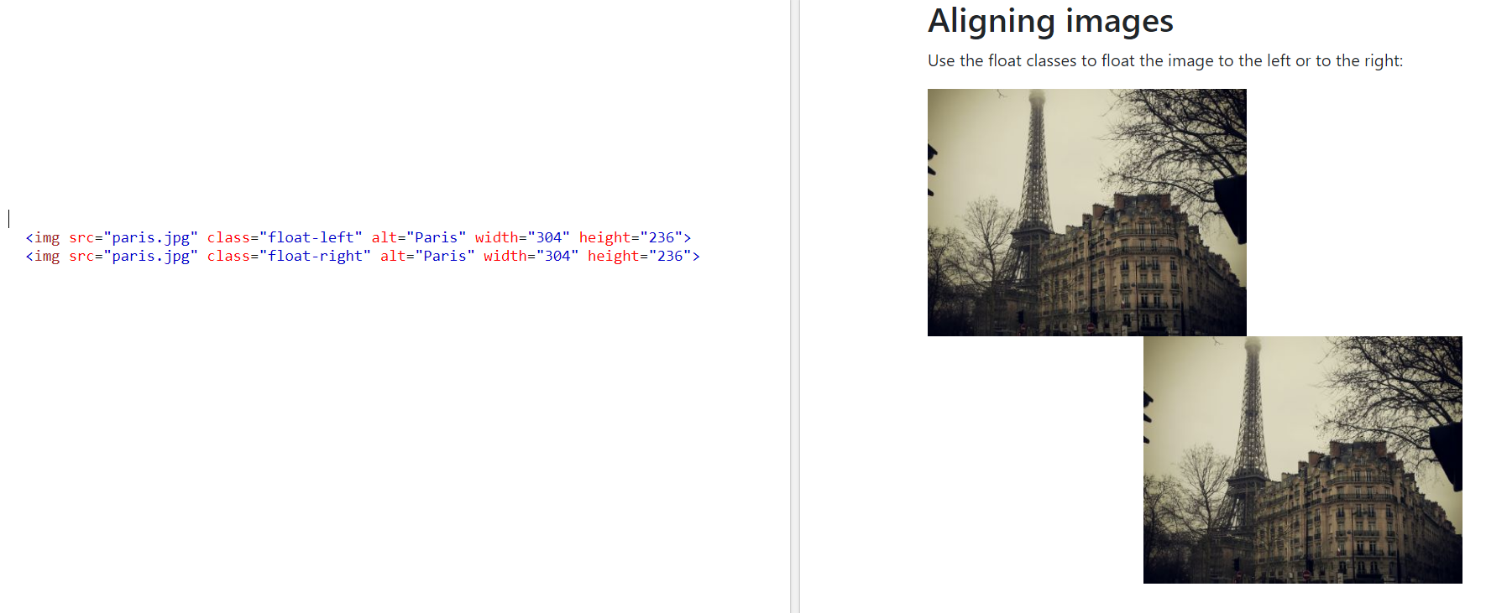

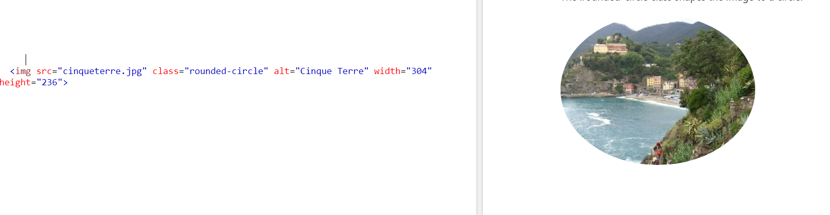

<img src="paris.jpg" class="mx-auto d-block" style="width:50%"> :: căn giữ

# **Bootstrap 4 Jumbotron**

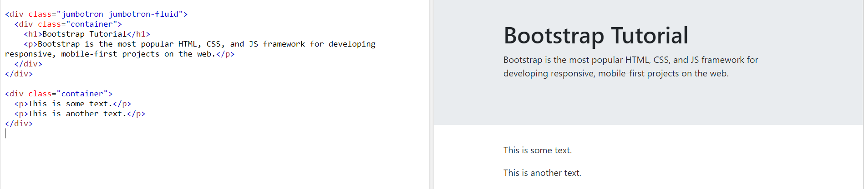

## Bootstrap 4 Alerts

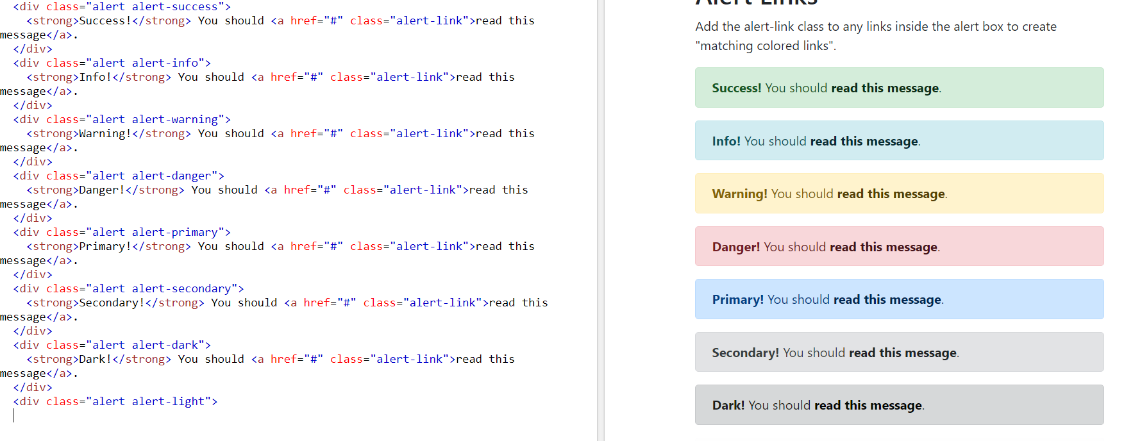

# **Bootstrap 4 Buttons**

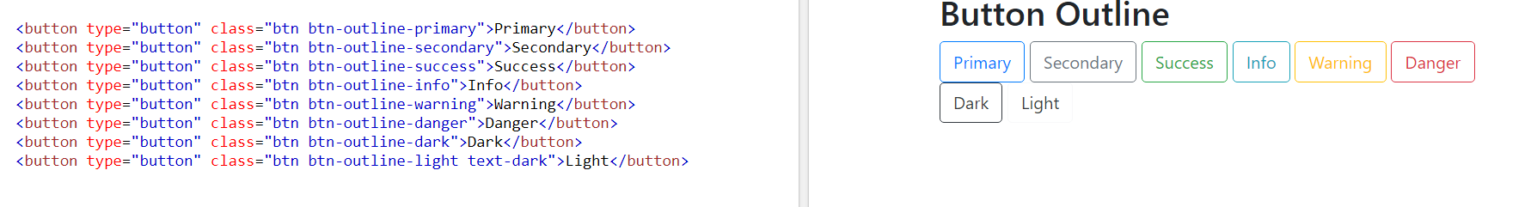





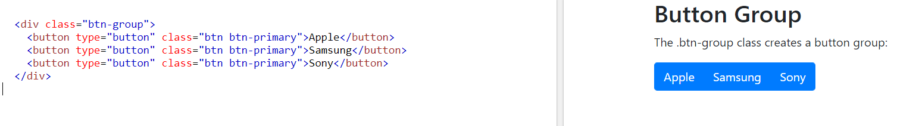

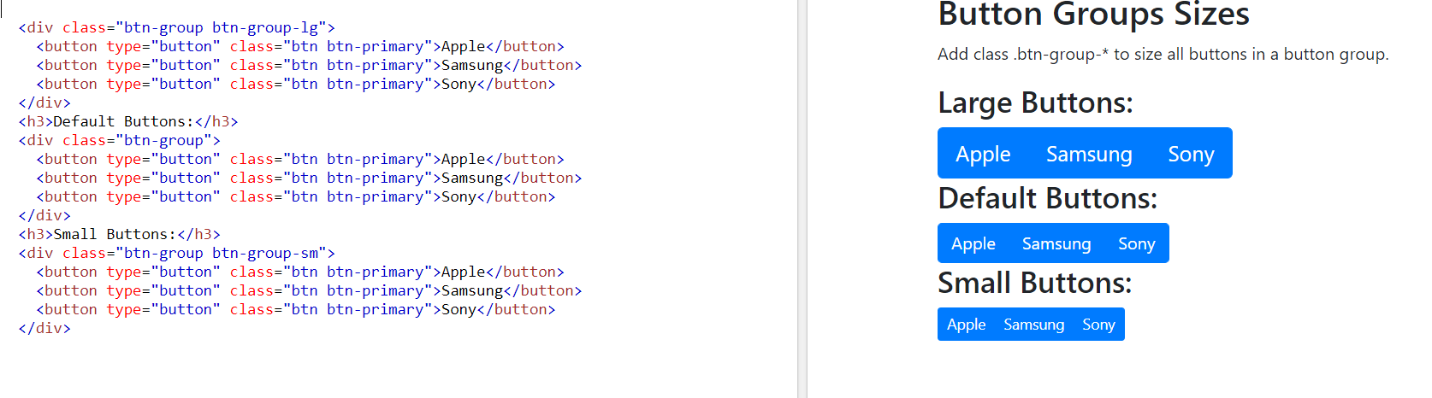

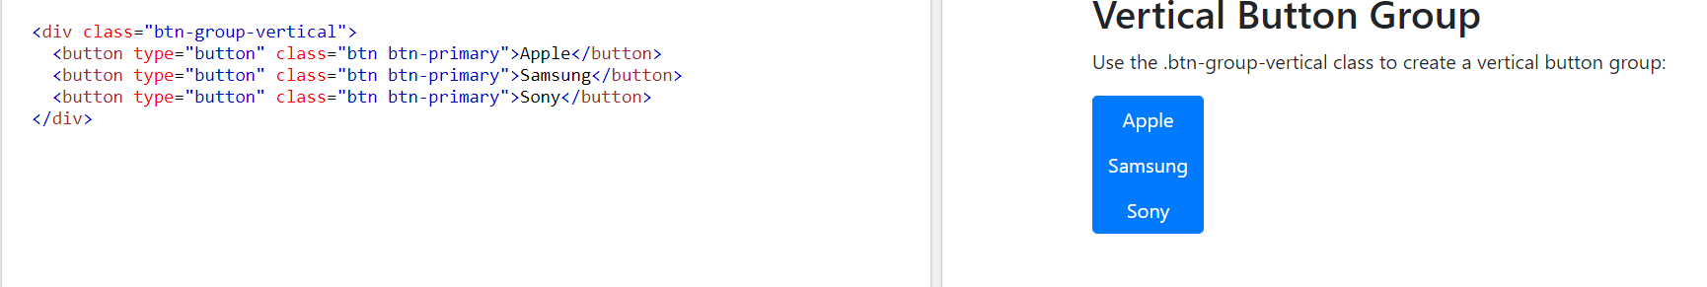

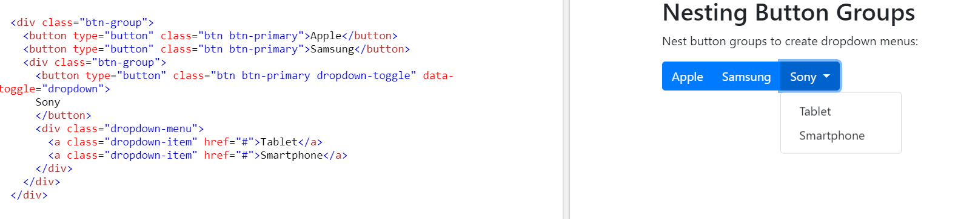

# **Bootstrap 4 Badges**

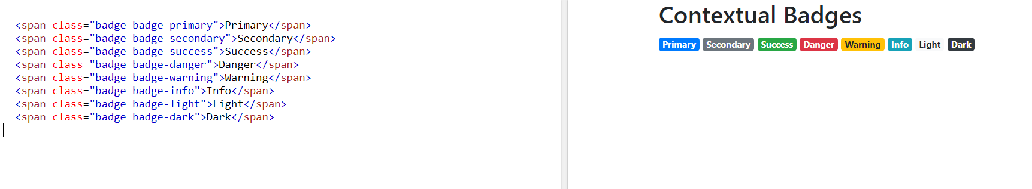

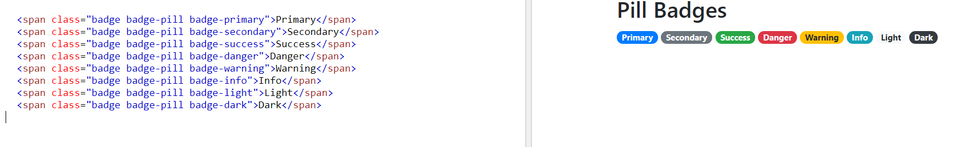

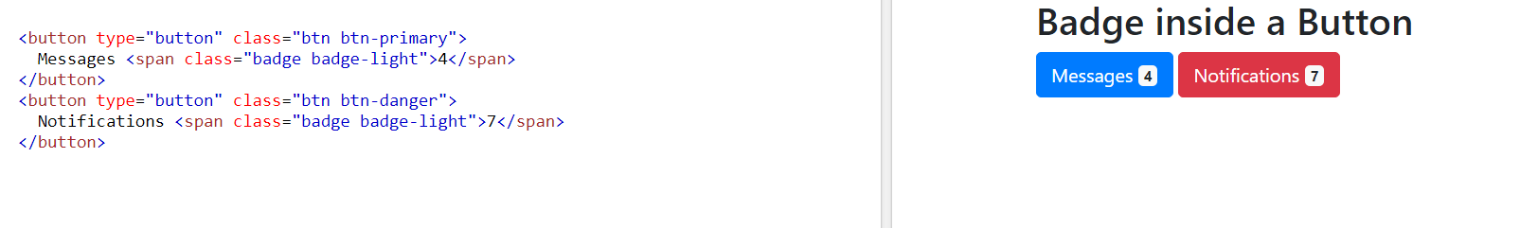

## Basic Progress Bar

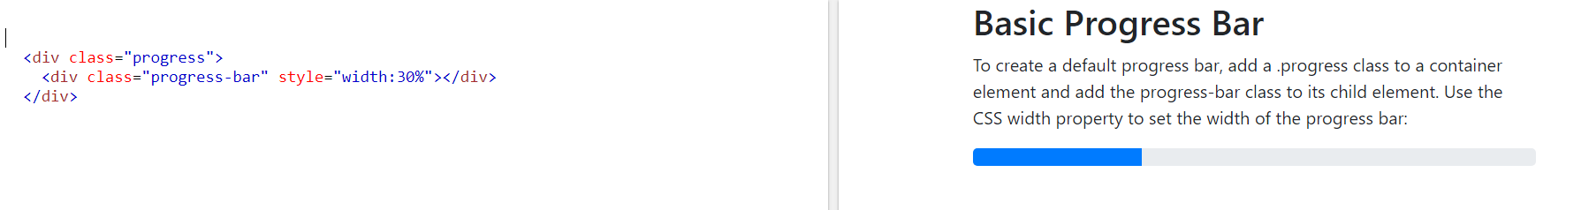

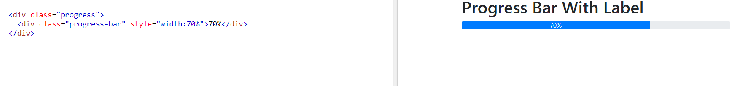

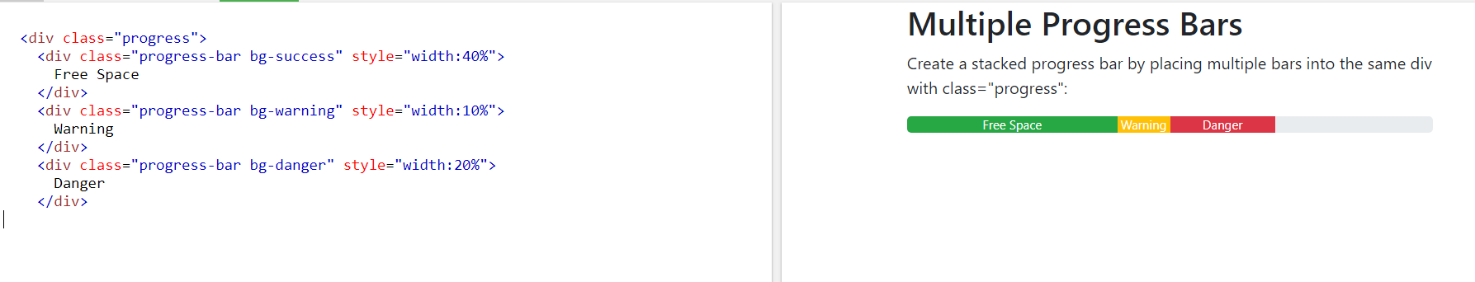

# **Bootstrap 4 Pagination**

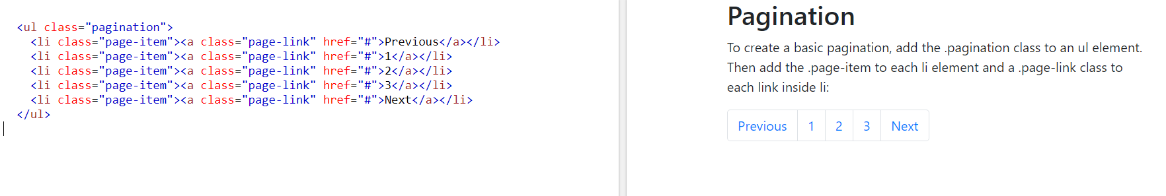

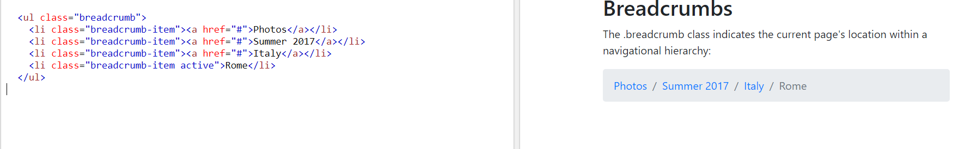

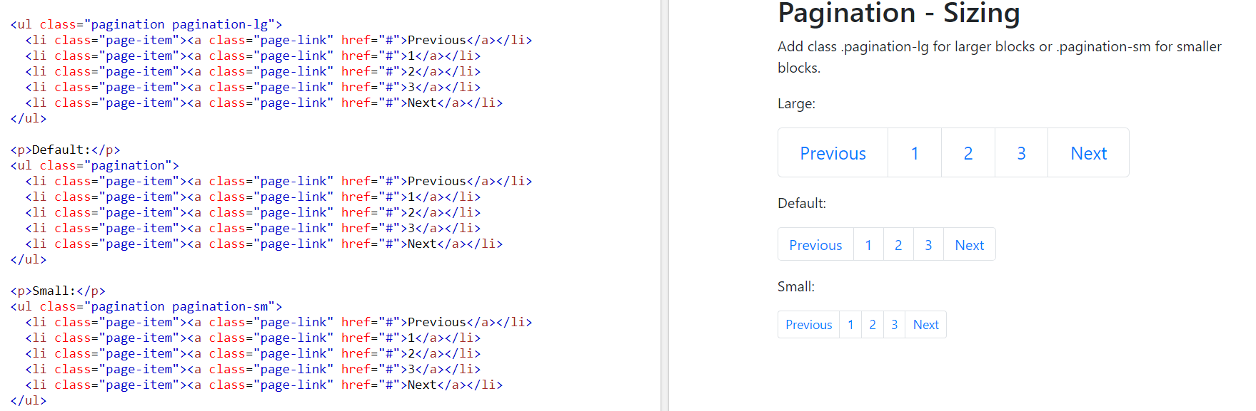

# **Bootstrap 4 List Groups**

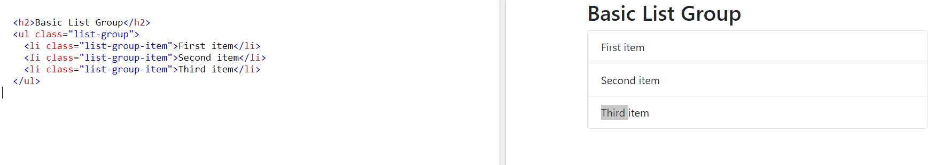

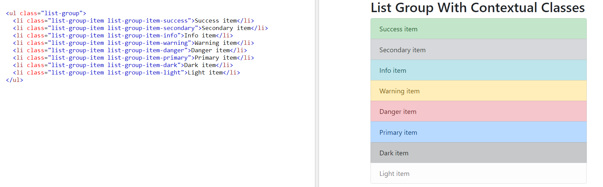

# **Bootstrap 4 Dropdowns**

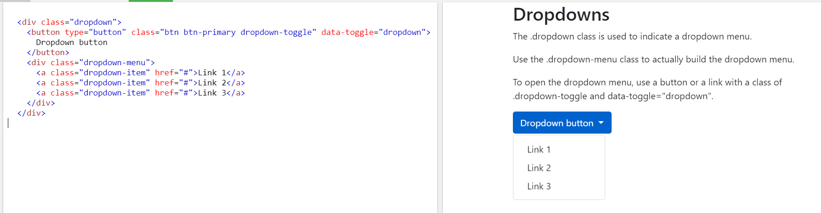

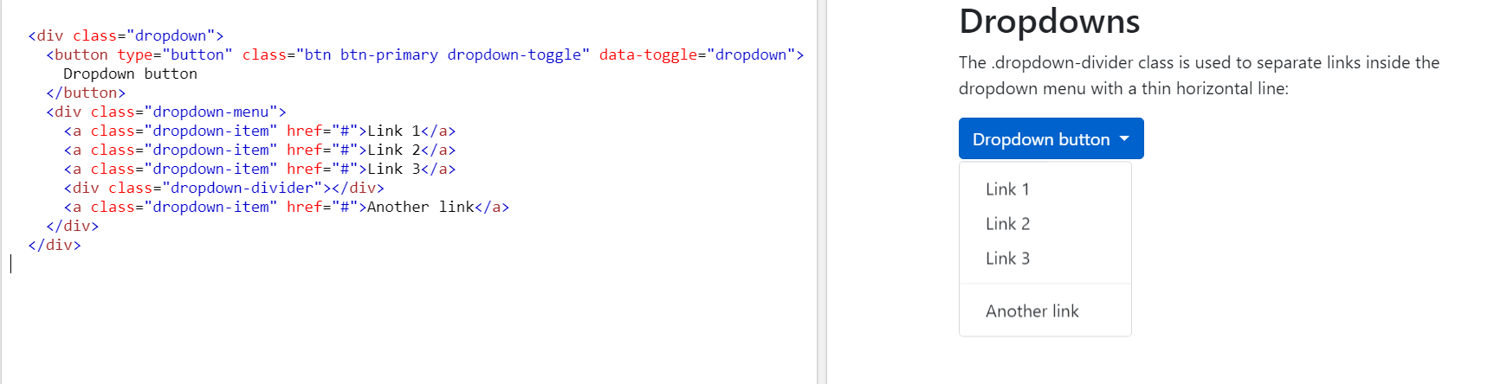

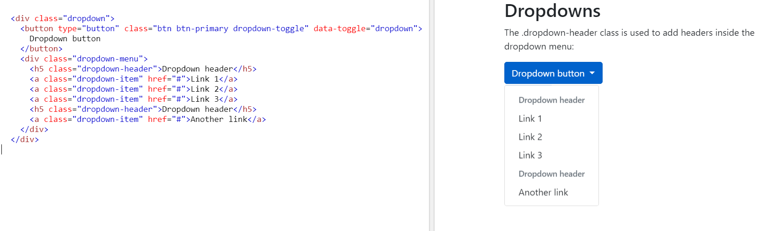

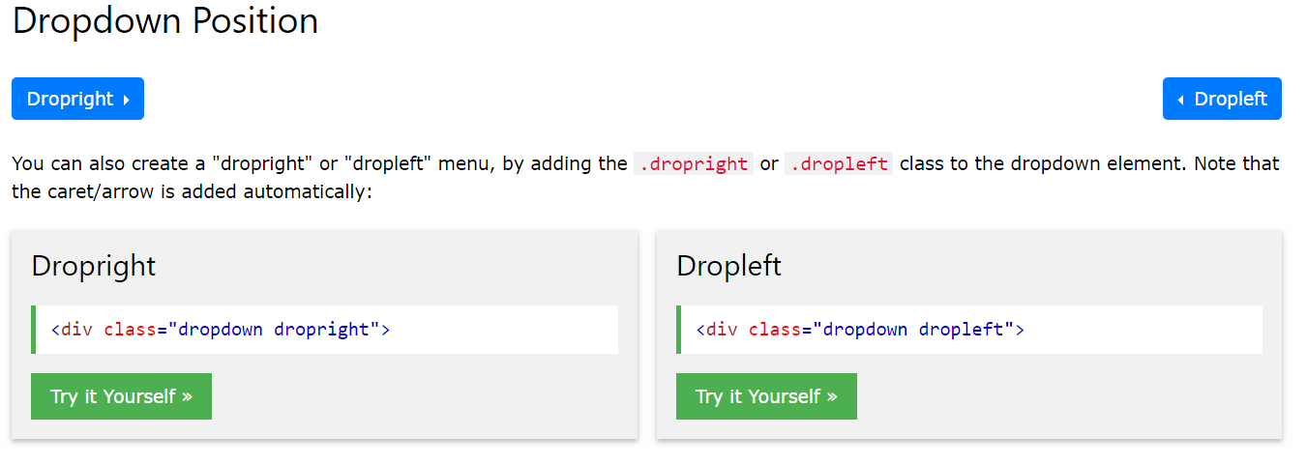

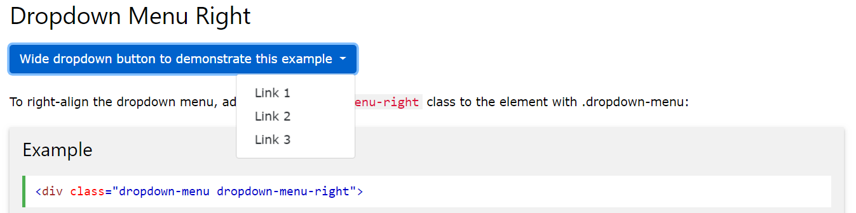

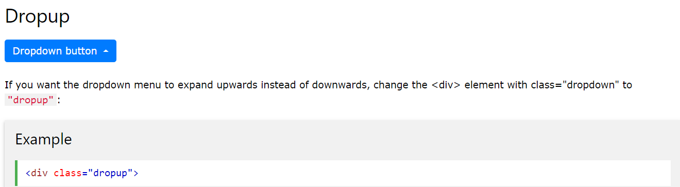

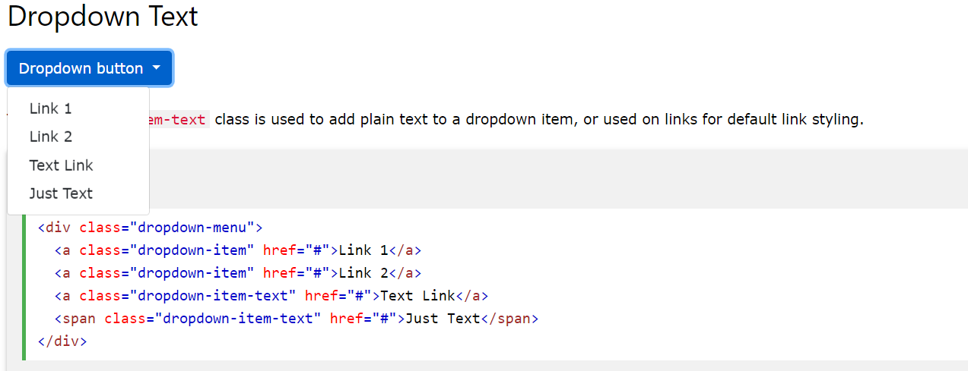

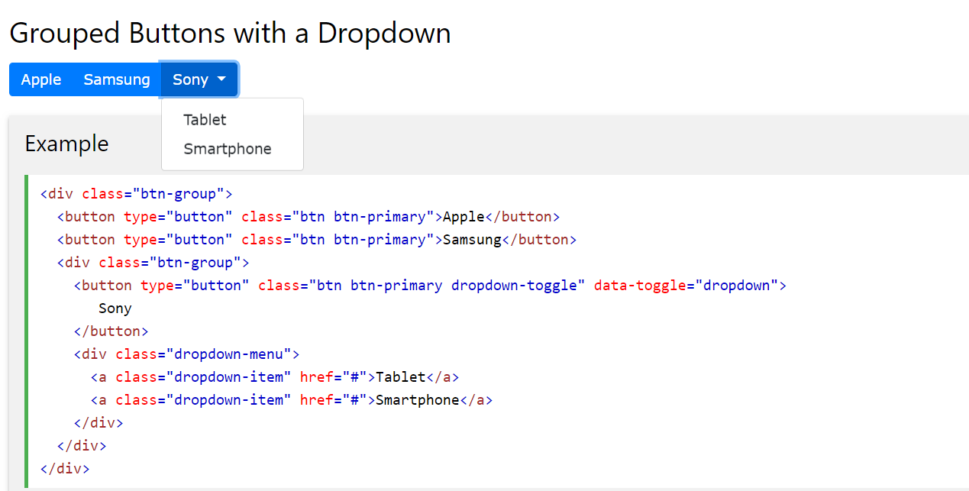

# **Bootstrap 4 Navs**

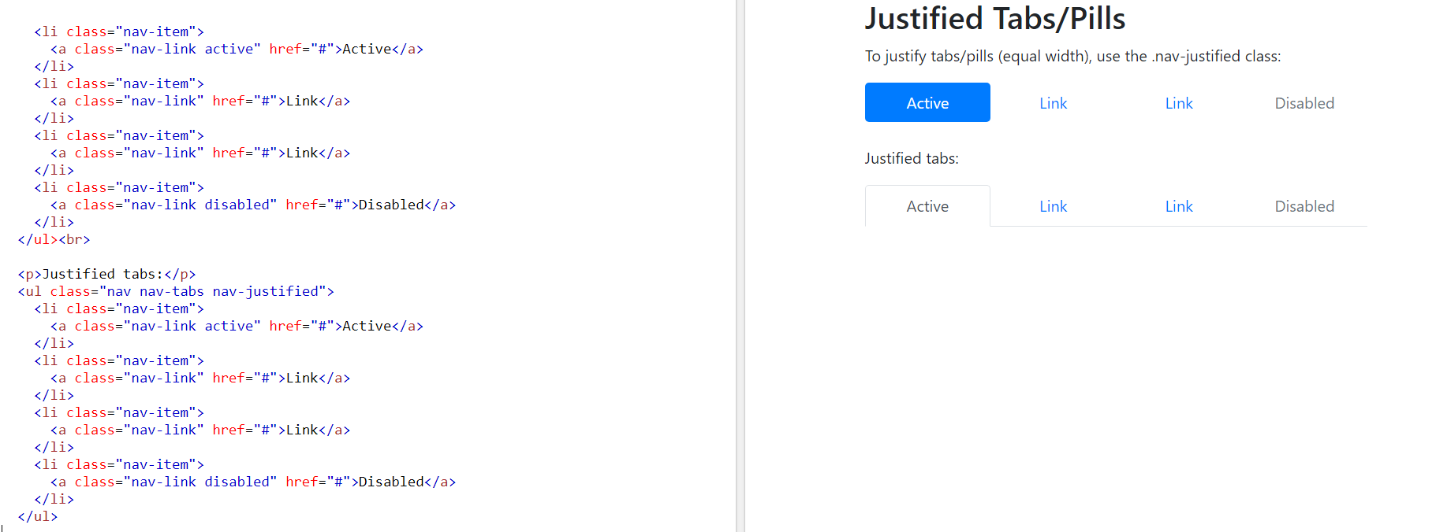

# **Bootstrap 4 Navigation Bar**

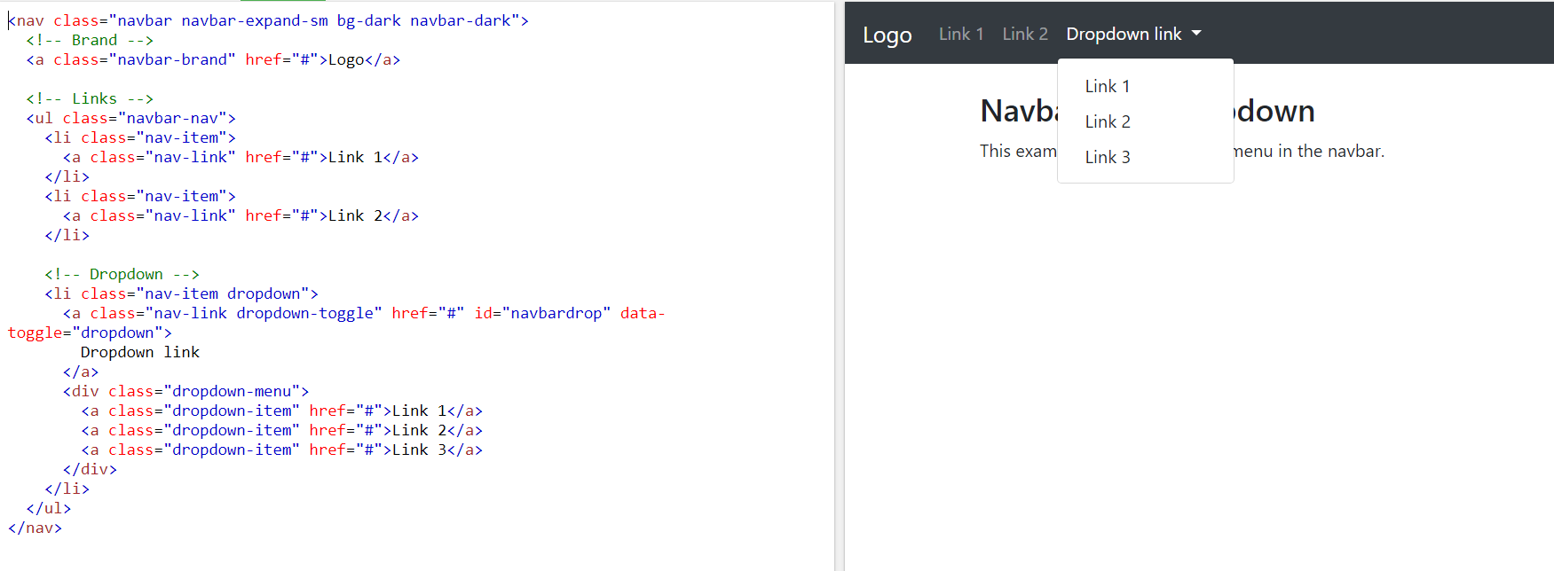

# **Bootstrap 4 Forms**

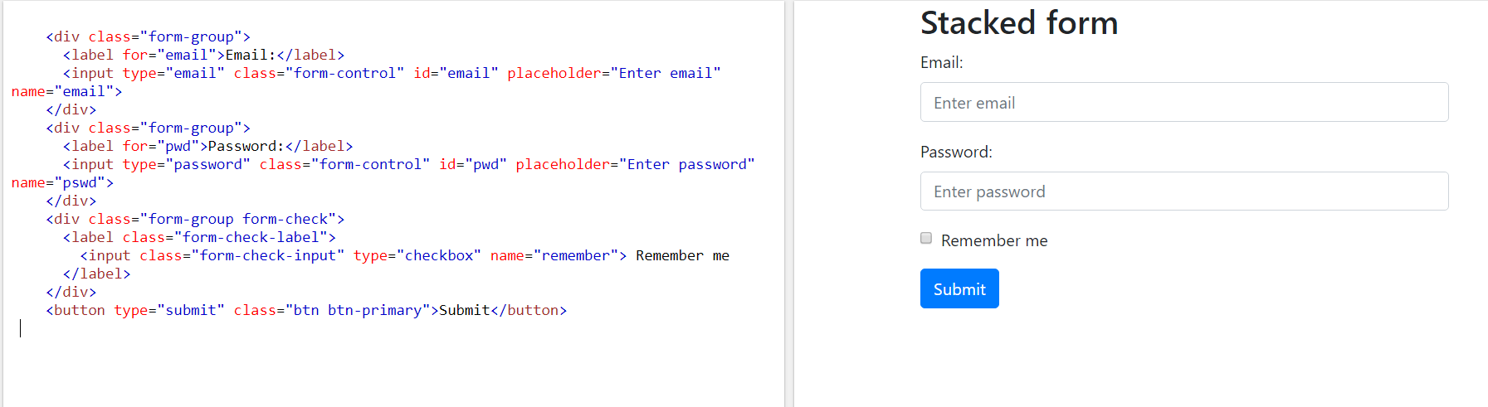

# **Bootstrap 4 Form Inputs**

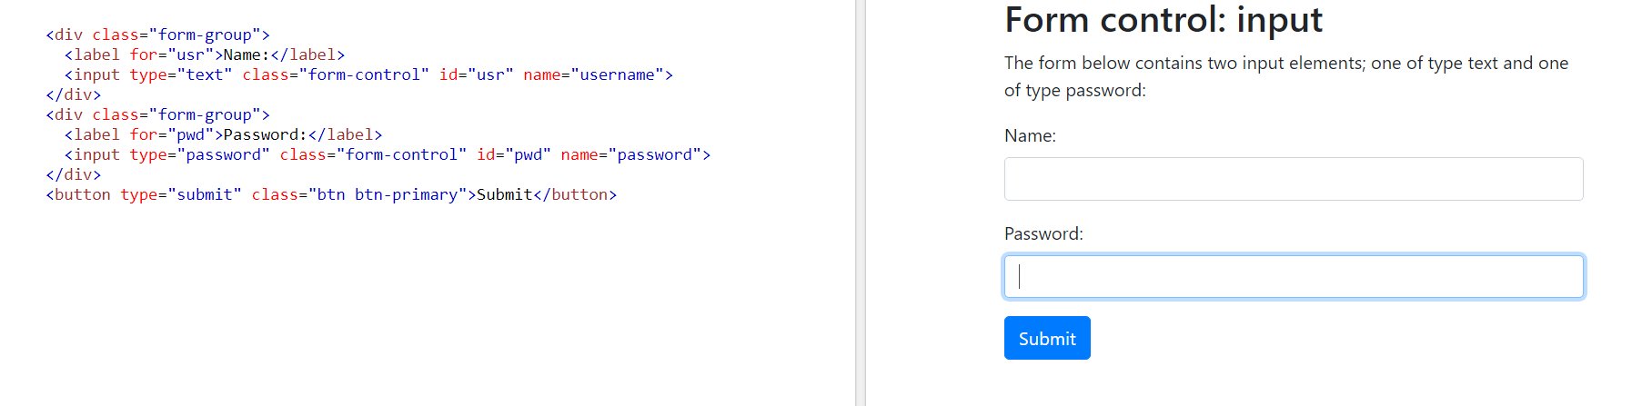

# **Bootstrap 4 Carousel**

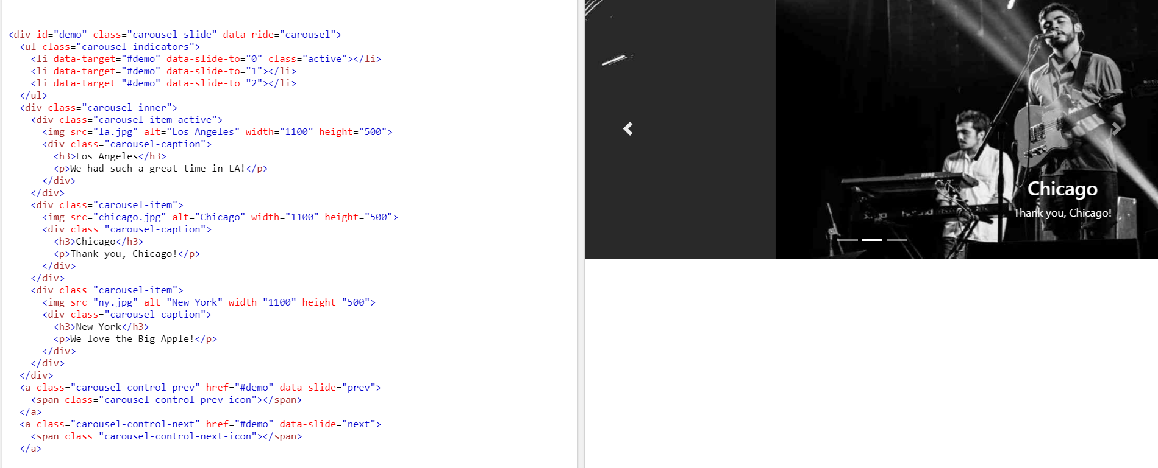

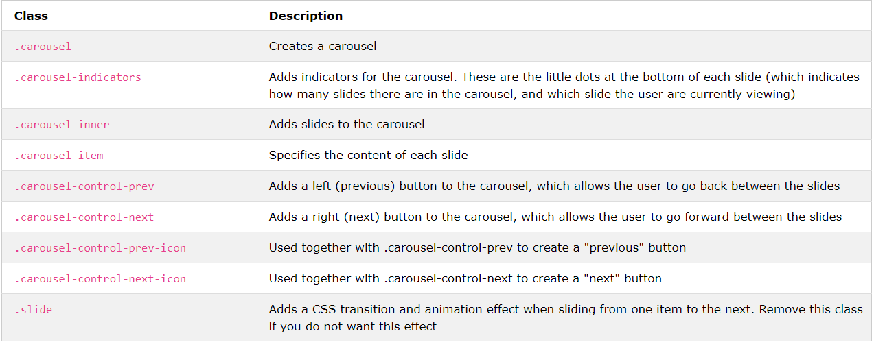

# **Bootstrap 4 Modal**

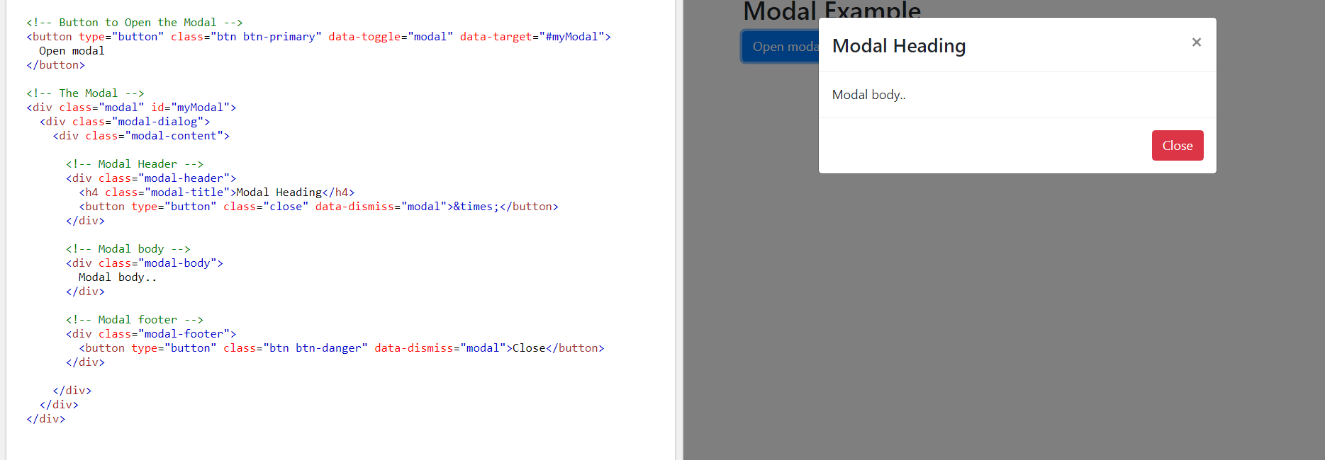

# **Bootstrap 4 Tooltip**

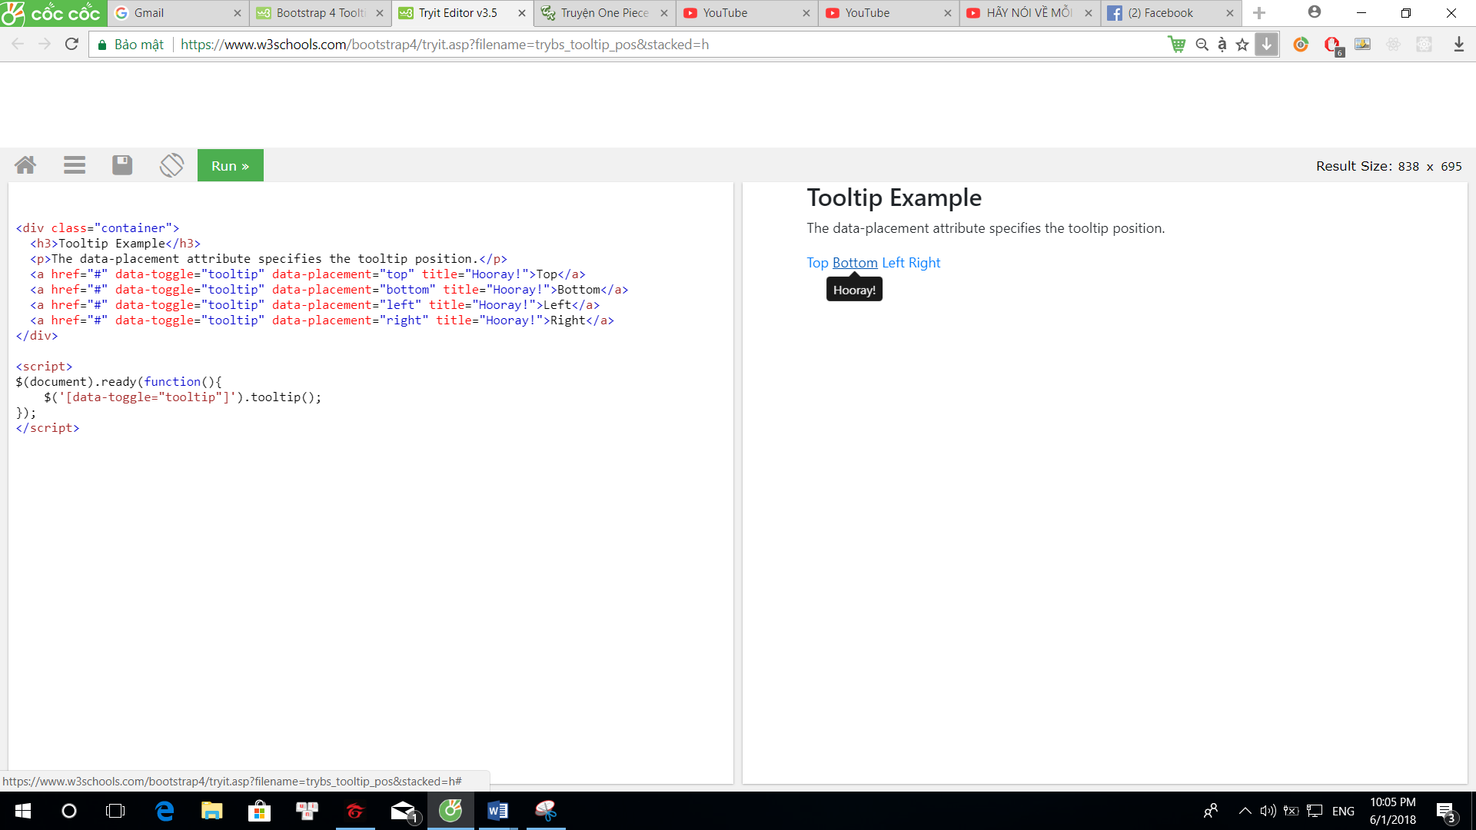

# **Bootstrap 4 Popover**

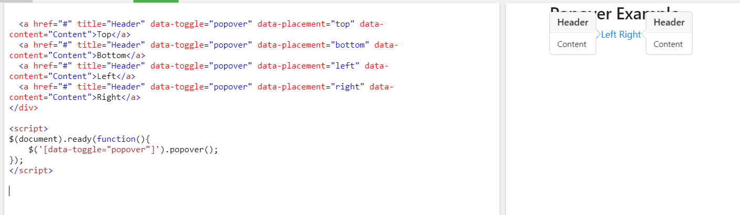

# **Bootstrap 4 Utilities**

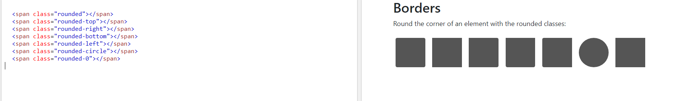

# **Bootstrap 4 Flex**

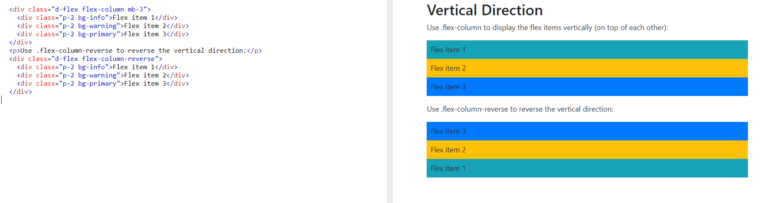

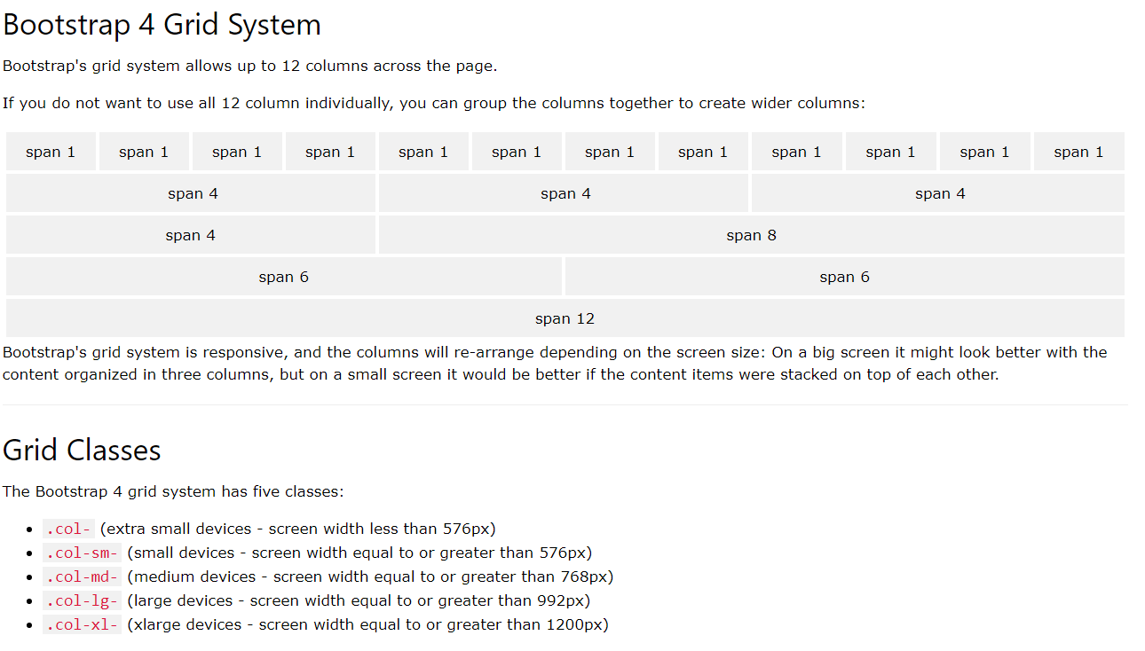

-------------------------------------------------------------------------------------------------------------------------------

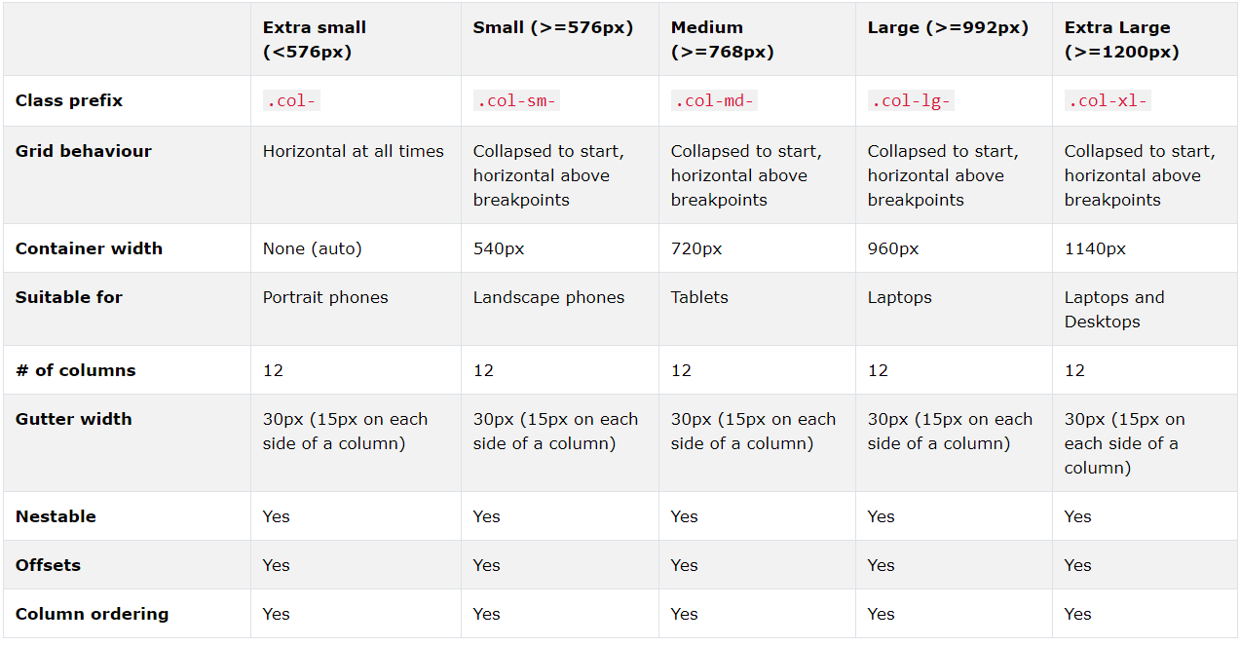

# **Bootstrap JS Tab**

